Art I - Perspective
Terms to Know

Horizon Line The horizon line represents the viewer's eye level. You can see the top of an object if it is below eye level, below the horizon line. If an object is above eye level, above the horizon line, you cannot see its top.

The horizon line is the place where the ground and sky seem to meet.

Vanishing Point The vanishing point, in one-point perspective, is always located on the horizon line. All lines meet at the vanishing point. As objects get closer to the vanishing point, they get smaller and smaller until they eventually appear to vanish.

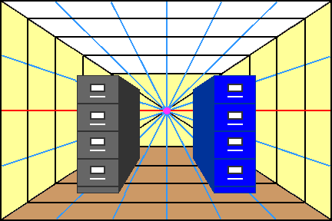
In the image at the left, notice the vanishing point in the center, where all lines converge. Notice the horizon line, on which the vanishing point sits.

Also notice, when the file cabinet is to the left of the vanishing point, we see its right side. When the cabinet is to the right of the vanishing point, we see its left side. The top is above the horizon line, so we cannot see its top. The bottom in below the horizon line so we cannot see its bottom.

